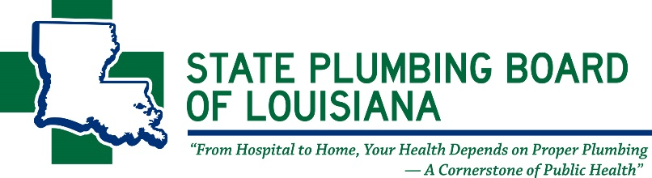
This form is to be used ONLY when your company is exempt from carrying Workers’ Compensation under the Louisiana Workers’ Compensation Laws.

Louisiana Workers’ Compensation Exemption Affidavit
If you hold multiple licenses, one (1) affidavit will suffice for all licenses.
EMPLOYING ENTITY
Full Company Name: _________________________________________________________________________________
Mailing Address: __________________________________________________ City:______________________________
State: ___________________ Zip: ______________________ Parish: __________________________________________
Please select the TYPE OF BUSINESS: Corporation LLC Sole Proprietorship Partnership
Please indicate owner(s) claiming exemption and the percentage of the ownership in the space provided:

Name of owner(s) claiming exemption Percentage of Ownership Signature
_______________________________ _______________________ _________________________________
_______________________________ _______________________ _________________________________
_______________________________ _______________________ _________________________________
_______________________________ _______________________ _________________________________

Note: By signing this affidavit, each owner affirms under the penalties of perjury that the information contained in this affidavit are true and correct. This document does not serve as proof of exemption, it only serves as documentation that the company owner(s) attest to being exempt under the Louisiana Workers’ Compensation Laws.

THIS OATH MUST BE TAKEN BEFORE AN OFFICER AUTHORIZED TO ADMINISTER OATHS

I, ________________________________________, am self-employed or an owner and I have no employees; therefore, I am exempt from the requirement to carry workers’ compensation insurance. If in the future, I should hire any employees that do not hold a percentage of the company, I will obtain workers’ compensation insurance coverage and submit a certificate of insurance to the State Plumbing Board immediately.

________________________________________
Signature

_______________________________ ______________________________
Witness Witness

Subscribed and sworn to before me this _______ day of __________________, 20_____.

Notary
Signature of Notary ______________________________

11304 CLOVERLAND AVENUE Baton Rouge, Louisiana 70809
Phone: (225) 756-3434 Fax: (225) 756-3433
www.spbla.com

